**Title: Longitudinal Data Analysis of the Effect of Maternal Immune Activation (MIA) vs. Control on Rhesus Monkeys’ Responsiveness to Profile and Stare Front Position in Human Intruder Test**

Min Kim

Graduate Group in Biostatistics at University of California, Davis

**Abstract**

Current studies on maternal immune activation (MIA) models of male offspring rhesus monkeys have shown the maternal immune activation as a potentially influential factor to subsequent male offspring’s neurobehavioral outcomes such as brain and cognitive development. The human intruder test (HI test) of non-human primate (NHP), rhesus monkeys, was designed to assess the responsiveness of male offspring rhesus monkey born to control or MIA-treated dams to the standardized conditions of a human intruder. This data analysis uses human intruder positioning data from HI test to compare their front duration under a human intruder’s “Profile” and “Stare” position. Each condition’s front duration was modeled by linear mixed effect model and the comparison of front duration across treatment group was assessed by statistical tests. The offspring born to MIA-treated dams shows very subtle difference in front duration from control-treated offspring over time which shows the evidence of MIA as an uninfluential factor to subsequent difference in measure of offspring neurodevelopmental behaviors.

**Introduction**

Maternal immune activation (MIA) models of rodents and nonhuman primates have shown their powerful and translational utility to extended exploration of neurobiological mechanisms underlying human neurodevelopmental disorders (Kentner, 2019).

MIA models which use the viral mimic immunostimulant, Polyinosinic: polycytidylic acid stabilized with poly-L-lysine (Poly ICLC) to stimulate maternal immune response during gestation enable systematic manipulation of maternal cytokine levels and evaluation of the offspring neurodevelopmental outcomes in a controlled environment (Vlasova, 2014).

A previous study has shown that “pregnant rhesus monkeys injected with a modified form of polycytidylic acid (Poly ICLC) at the end of the first or second trimester exhibited a transient but potent immune response and produced offspring that deviated from species-typical behavioral development” (Bauman, 2014).

*Human Intruder Test*

“The human intruder test (HI test) is a testing paradigm designed to measure rhesus monkeys’ behavioral responses to a stressful and threatening situation. In the test, an unfamiliar human positions him/herself in various threatening positions relative to a caged macaque” (Gottlieb, 2013).

From a current longitudinal study conducted in a non-human primates MIA model, the human intruder test was conducted on male offspring rhesus monkeys (Macaca mulatta) born to MIA-treated dams (n = 14) injected with modified form of the viral mimic Poly ICLC and Control dams received saline injections at the same gestational time point (n = 10) or untreated (n = 4) at the end of the 1st trimester.

The goal of this human intruder test is to assess the rhesus monkeys’ behavioral responses under standardized conditions of a human intruder. The study question of interest is to see whether there is a group difference in “Front” duration under “Profile” and “Stare” conditions between the group of male offspring of MIA-treated dams (MIA group) and the group of male offspring of control dams (control group).

**Methods**

The study data is the human intruder positioning data of HI test from a current longitudinal study on 28 male offspring of rhesus monkeys born to MIA-treated dams (n = 14) and to control dams (n = 14).

The data keeps track of position in cage as “duration” in the four quadrants of the cage during HI test of animals at approximately 1, 3, 6, 23, and 35 months of age.

The animals are placed in a top cage. After a one-minute baseline period has expired, the unfamiliar human observer will enter the room and start the stopwatch once in position. Each of the selected animals was tested in a single session comprised of 4 one-min trials of 4 conditions of a human observer: Profile Far, Profile Near, Stare Far, and Stare Near.

To define the outcome, duration in “Front”, this analysis uses the average of front duration summed Profile Far (PF) and Near (PN) conditions: (PF + PN)/2 at each time point to indicate “Profile Front Duration” of an animal at each time point and the average of front duration summed Stare Far (SF) and Stare Near (SN) conditions (SF + SN)/2 at each time point to indicate “Stare Front Duration.”. This strategy to combine Far and Near conditions for the outcome is common in the previous literatures about HI test on rhesus monkeys.

To model the front duration, this analysis has 2 separate models for front duration in profile and stare conditions separately, with age of animals and treatment group (MIA and control). The actual age of the animals in days, days from birthdate to test date, show that there is about difference of 10 days in mean ages between MIA and control groups at both 23 and 35 months. To account for this difference, the analysis uses the continuous actual age of the animals in months. The age variable in the 2 models is in months, centered at 1 month.

The two models for profile front and stare front durations are the linear mixed-effect models (LMM) for normally distributed continuous outcomes and initially include fixed effects for treatment group (MIA, control), linear, quadratic, and cubic age centered at 1 month, and the interaction between the treatment group and the centered linear, quadratic, and cubic age. Exchangeable correlation structure is chosen to account for within-animal dependence (details in Model Selection).

*Initial Model*

Let $Y_{\left\{ij\right\}}$ be the front duration for subject i for either profile or stare and $Age_{\left\{ij\right\}}$ be subject’s age, for i = {1,…, $n_{i}$}, at time point j = $\left\{1,…,n_{j}\right\}$, and $Treatment_{\left\{i\right\}}$ be the indicator variable for $Treatment_{\left\{i\right\}}$ = 1 for MIA, and $Treatment_{\left\{i\right\}}$ = 0 for control group. Consider the full model

$$Y_{\left\{ij\right\}}= β_{0}+ β_{1}\left\{Treatment_{\left\{i\right\}}\right\}+ β_{2} \left\{Age_{\left\{ij\right\}}-1\right\}+β_{3}{\left\{Age_{\left\{ij\right\}}-1\right\}}^{2}+ β_{4}{\left\{Age_{\left\{ij\right\}}-1\right\}}^{3}+ β_{5}\left\{Treatment_{i}\right\}*\left\{Age_{\left\{ij\right\}}-1\right\}+ β_{6}\left\{Treatment_{i}\right\}*{\left\{Age_{\left\{ij\right\}}-1\right\}}^{2}+ β_{7}\left\{Treatment_{i}\right\}*{\left\{Age_{\left\{ij\right\}}-1\right\}}^{3}+ e_{\left\{ij\right\}}$$

, where

$$e_{\left\{ij\right\}}= U_{0i}+Z_{ij}$$

with i.i.d. measurement error $Z_{ij}$, and $U_{0i}$ is random intercept independent for each subject i, with

$Z_{ij}\sim N\left(O, τ^{2}\right)$,

$\left(U_{0i}\right) \sim N\left(0,G\right)$, $U_{0i}⊥Z_{ij}$,

E $\left(U_{0i}\right)$ = $(0)$, Var $\left(U_{0i}\right)$ = G = $\left(\begin{matrix}σ_{0i}^{2}\end{matrix}\right)$.

*Model Selection*

For both models of profile and stare front durations, to account for the within-animal dependence, exchangeable correlation structure is used and chosen over exchangeable correlation structure with random slope and exchangeable correlation plus exponential considering the BIC of models of profile front duration with three correlation 1206.569, 1216.258, 1221.052, respectively, and BIC for models of stare front duration, 1186.714, 1196.510, and1191.550, respectively with lowest BIC of exchangeable correlation structure.

For both models of profile and stare front durations, possible inclusion of random slope for each subject into the covariance model is considered and assessed by Bayesian information criterion (BIC). The candidate random intercept and slope covariance model has the following form:

$$e_{\left\{ij\right\}}= U_{0i}+U_{1i}\{Age_{\left\{ij\right\}}-1\}+ Z_{ij}$$

, where

$U_{0i , }U_{1i}⊥Z_{ij}$, $U_{0i}$ and $U_{1i}$ are allowed to be correlated with

$\left[\begin{aligned}U_{0i} \\ U_{1i}\end{aligned}\right]$ $\sim N\left(0, G\right)$, $E\left[\begin{aligned}U_{0i} \\ U_{1i}\end{aligned}\right]$ = $\left[\begin{aligned}0 \\ 0\end{aligned}\right]$, $Var\left[\begin{aligned}U_{0i} \\ U_{1i}\end{aligned}\right]$ = G = $\left(\begin{matrix}σ_{0i}^{2} & σ_{0i}σ_{1i} \\ σ_{1i}σ_{0i} & σ_{1i}^{2}\end{matrix}\right)$.

The profile front duration model with random intercept only covariance model yields BIC of 1206.569, whereas the model with random intercept and slope yields BIC of 1216.258. The random intercept only covariance model that yields lower BIC is chosen for profile front duration model.

For stare front duration model with random intercept only covariance model which yields BIC of 1186.714 is chosen over the model with both random intercept and slope which yields BIC 1196.510. For both profile and stare front duration model, the covariance models with lowest BIC, random intercept only, are chosen and the random slopes are not included in both models.

For both models of profile and stare front durations, the presence of the fixed effects in the model is assessed by tests for treatment effect, linear, quadratic, cubic age (centered at 1 month) and the interaction terms of treatment and linear, quadratic, cubic age using t-test and F-test. Main effect of treatment is always kept since this is of primary interest.

For profile front duration model, interaction terms and higher order age terms are removed sequentially if they are not significant. For profile front duration, all interactions terms are found to be not significant as well as linear age effect and treatment effect. However, the final model for profile front duration includes treatment effect and linear age effect which is not statistically significant but can potentially explain the relationship between the profile front duration.

For stare front duration model, interaction terms and higher order terms are removed sequentially if they are not significant. The linear, quadratic, and cubic age are found to be significant after removal of the interaction terms while treatment effect is found to be not significant. The final stare front duration model includes linear, quadratic, and cubic age effects and treatment effect while treatment effect can potentially explain the relationship between stare front duration even though it is not significant.

**Results**

*Exploratory Analysis*

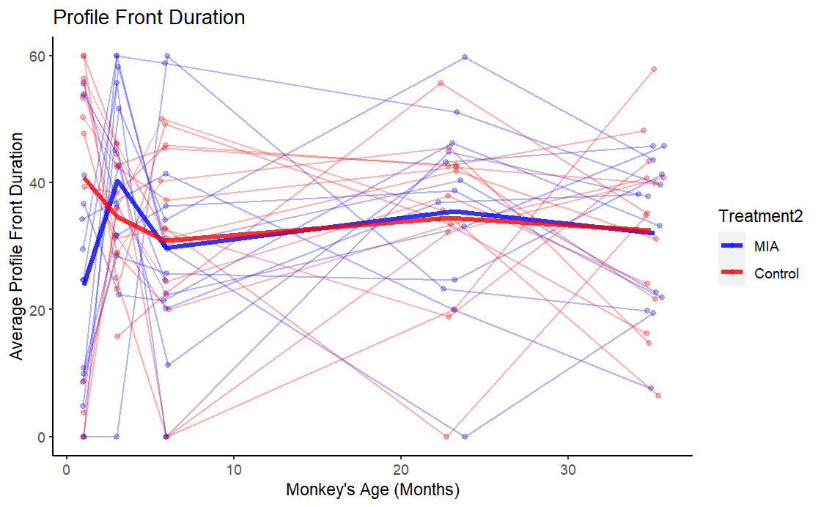

Figure 1. Plot of Profile Front Duration with Individual Trajectories and Mean Trend by Treatment Group over Time (Months)

Figure 2. Plot of Stare Front Duration with Individual Trajectories and Mean Trend by Treatment Group over Time (Months)

Figures 1 and 2 show the plots of the profile and stare front duration of individual trajectories and mean trend, respectively, by age in months and grouped by treatment group. The clusters around each time point show the variation of front duration at each time point for both profile and stare conditions. Both plots suggest possible inclusion of a random intercept in the model. The plot of profile front duration shows that there may be subtle variation over time, subtle variation across treatment group, or both. The plot of stare front duration shows that there may be variation in time, subtle variation across treatment group, or both. The mean trend of both the profile front duration and stare front duration suggests possible linear, quadratic, and cubic age effect.

*Descriptive Statistics*

**

Table 1 shows the descriptive summary statistics for the variables used in this analysis. From table 1, we can see that the sample sizes are different at each time point. There are a few monkeys that are not tested at all time points due to health-related issues. One offspring from the MIA group was euthanized at 6 months due to an unrelated health condition and is not included in datasets after 6 months of age.

As previously mentioned, there is an age difference in mean and median between MIA and control group at 23- and 35-month time point. At 23 months, there is a mean age difference of 10 days within MIA group and the range of age in days of MIA group is 48 days which is more than a month difference. To account for this difference, adjustment of age variable to the actual age days converted to scale of months which gives more accurate measure is used in this analysis.

The mean difference of front duration between MIA and control group under profile and stare condition is the biggest at 1 month and decreases over time. The mean profile and stare front duration is highest at 3 months for MIA group, while the control group has highest mean profile and stare duration at 1 month.

A further statistical analysis on possible difference of profile/stare front duration between MIA and control group at baseline 1 month was conducted by fitting ordinary linear regression on 1 month only profile/stare front duration with treatment and centered linear age at 1 month as a predictor. From the parametric t-test results, the treatment effect at 1 month is found to be statistically not significant for both profile front duration (p = 0.058) and stare front duration (p = 0.114) (See Appendix: Table 3 for details of linear model results and Figures 3 and 4 for model diagnostics). The non-parametric Mann Whitney U-test for comparing profile front duration of MIA and control group at 1 month suggests significant difference between profile front duration across treatment group (p = 0.04) (See Appendix: Figures 5 and 6 for details of Mann Whitney U-test results).

*Linear Mixed-Effects Models*

Let $Y_{\left\{ij\right\}}$ be the front duration for subject i for either profile or stare and $Age_{\left\{ij\right\}}$ be subject’s age, for i = {1,…, $n_{i}$}, at time point j = $\left\{1,…,n_{j}\right\}$, and $Treatment_{\left\{i\right\}}$ be the indicator variable for $Treatment_{\left\{i\right\}}$ = 1 for MIA, and $Treatment_{\left\{i\right\}}$ = 0 for control group.

The final LMM mean model for profile front duration is

$$Y_{\left\{ij\right\}}= β_{0}+ β_{1}\left\{Treatment_{\left\{i\right\}}\right\}+ β_{2}\{Age_{\left\{ij\right\}}-1\}+U_{\left\{0i\right\}}+Z_{\left\{ij\right\}}$$

The final model includes 2 fixed effects: treatment and linear age (centered at 1 month) effect. All other terms including interactions were excluded.

The final LMM mean model for stare front duration is

$$Y_{\left\{ij\right\}}= β_{0}+ β_{1}\left\{Treatment_{\left\{i\right\}}\right\}+ β_{2}\{Age_{\left\{ij\right\}}-1\}+β_{3}{\{Age_{\left\{ij\right\}}-1\}}^{2}+ β_{4}{\{Age_{\left\{ij\right\}}-1\}}^{3}+U_{\left\{0i\right\}}+Z_{\left\{ij\right\}}$$

, where

$Z_{ij}\sim N\left(O, τ^{2}\right)$, $\left(U_{0i}\right) \sim N\left(0,G\right)$, $U_{0i}⊥Z_{ij}$,

E $\left(U_{0i}\right)$ = $(0)$, Var $\left(U_{0i}\right)$ = G = $\left(\begin{matrix}σ_{0i}^{2}\end{matrix}\right)$

The final LMM model for stare front duration includes 4 fixed effects: treatment: linear quadratic, and cubic age (centered at 1 month) effects.

|  |  |  |  |  |  |
| --- | --- | --- | --- | --- | --- |
| **Table 2: Fixed-Effect Parameter Estimates (SE) for the linear mixed-effects models predicting Profile and Stare Front Duration** | | | | | |
|  | | | | | |
|  | *Dependent variable:* | | | | |
|  |  | | | | |
|  | Profile Front Duration | | | Stare Front Duration | |
| Model Term | Estimate (SE)  p-value | | | Estimate (SE)  p-value | |
|  | | | | | |
| Intercept | | 34.585***(2.393) | 31.811***(3.05) | |
|  | | p = 0.000 | p = 0.000 | |
| Treatment: MIA vs. Control | -2.353 (2.793) | | | 1.514 (2.633) | |
|  | p = 0.408 | | | p = 0.571 | |
| Linear Age | -0.008 (0.105) | | | 2.559** (1.216) | |
|  | p = 0.937 | | | p = 0.038 | |
| Quadratic Age |  | | | -0.203** (0.086) | |
|  |  | | | p = 0.021 | |
| Cubic Age |  | | | 0.004**(0.020) | |
|  |  | | | p = 0.024 | |
|  | | | | | |
| Observations | 135 | | | 135 | |
|  | | | | | |
| Note: | *p<0.01**p<0.05***p<0.01 | | | | |

Profile front duration models were fitted with fixed effects for treatment group (MIA vs. Control), and linear age. Stare front duration model were fitted with fixed effects for treatment, linear, quadratic, and cubic age terms. The interaction terms between treatment and age and higher order age effects were removed if non-significant. The intercept can be interpreted as the predicted profile/stare front duration at baseline 1 month for Control group (baseline group in this model). Treatment: MIA vs. Control can be interpreted as the estimated difference in mean profile/stare front duration comparing MIA group to control group over time. The linear age, quadratic, and cubic age can be interpreted as the difference in mean profile/stare front duration for each unit increase in linear, quadratic, and cubic age in control group.

Table 2 demonstrates the fixed effects parameter estimates for the final LMM Model for 2 separate models: profile front duration and stare front duration.

The result of Table 2 shows that there is no interaction effect between the age and treatment group for both profile and stare front duration. The treatment effect is not different over time with the difference in profile front duration between MIA and control group that is found to be not statistically significant. (Estimated difference: -2.353, p = 0.408). The age effect is not significantly statistically different across MIA and control group for profile front duration. (Estimated difference: -0.008, p = 0.937).

For stare front duration, the treatment effect is not different over time with the difference in stare front duration between MIA and control group that is found to be not statistically significant. (Estimated difference: 1.514, p = 0.571). The age effect is not significantly statistically different across MIA and control group while linear, quadratic, and cubic age effects on stare front duration are found to be statistically all significant. (p = 0.038, p = 0.021, p = 0.024­).

*Model Diagnostics*

We evaluated the fitted models of profile and stare front duration by fitted mean functions of coefficient estimates (Figure 3 and 4) and compared to observed mean. The stare front duration model with treatment effect, linear, quadratic, and cubic age effect seems to capture the mean trends of MIA and control group, whereas the profile front duration model with treatment effect and linear age effect might not capture the mean trends of MIA and control group well. Conditional residual plots show random spread of residuals and constant variance for both profile and stare front duration (See Appendix for detailed diagnostics plots).

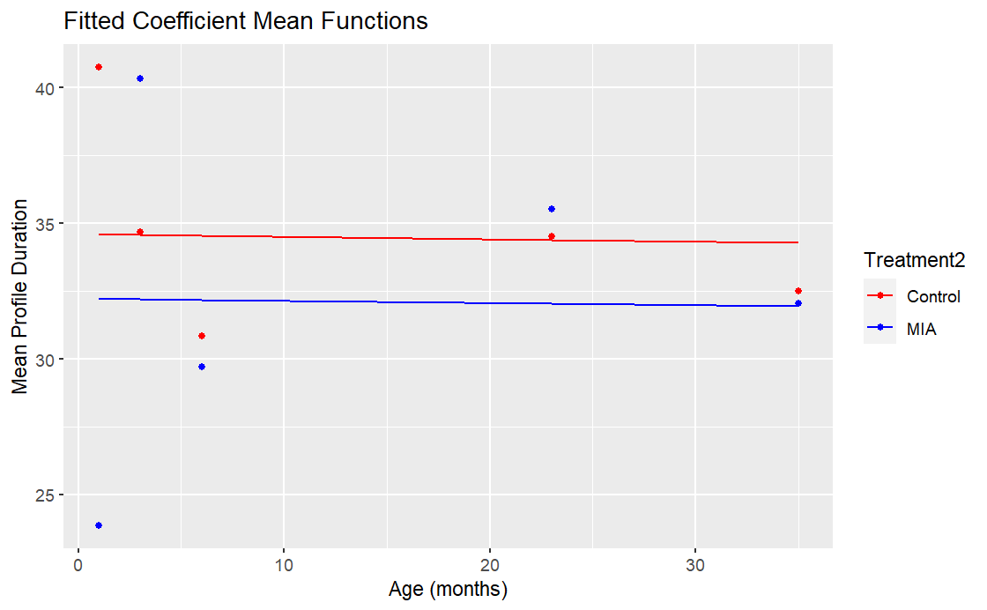

Figure 3 Plot of fitted mean functions of coefficient estimates for mean profile front duration (Left)

Figure 4 Plot of fitted mean functions of coefficient estimates for mean stare front duration (Right)

**Discussion**

In this analysis, we investigated whether the duration in “Front” position of the male offspring of MIA-treated dams and control dams to a human intruder’s profile and stare differ by treatment. From the linear mixed-effects model, we found out that there is no statistically significant treatment effect over time for both profile and stare conditions. We found out thatthe age effect is same across MIA and control group linear age effect is not significant for profile front duration while linear, quadratic, and cubic age are significant for stare front duration. Overall, it appears that MIA-treated offspring performed similarly to the control offspring under profile and stare front conditions. A further analysis can be conducted with different outcome measures from the HI test such as investigating on possible treatment group difference in frequency of position change or various types of behaviors.

**References**

Bauman, M. D., A. M. Iosif, S. E. Smith, C. Bregere, D. G. Amaral and P. H. Patterson (2014). "Activation of the maternal immune system during pregnancy alters behavioral development of rhesus monkey offspring." Biol Psychiatry 75(4): 332-341.

Gottlieb DH, Capitanio JP. “Latent variables affecting behavioral response to the human intruder test in infant rhesus macaques (Macaca mulatta).” Am J Primatol. 2013 Apr;75(4):314-23. doi: 10.1002/ajp.22107. Epub 2012 Dec 10. PMID: 23229557; PMCID: PMC3581725.

Kentner AC, Bilbo SD, Brown AS, Hsiao EY, McAllister AK, Meyer U, Pearce BD, Pletnikov MV, Yolken RH, Bauman MD. “Maternal immune activation: reporting guidelines to improve the rigor, reproducibility, and transparency of the model.” Neuropsychopharmacology. 2019 Jan;44(2):245-258. doi: 10.1038/s41386-018-0185-7. Epub 2018 Aug 21. PMID: 30188509; PMCID: PMC6300528.

Vlasova RM, Iosif AM, Ryan AM, Funk LH, Murai T, Chen S, Lesh TA, Rowland DJ, Bennett J, Hogrefe CE, Maddock RJ, Gandal MJ, Geschwind DH, Schumann CM, Van de Water J, McAllister AK, Carter CS, Styner MA, Amaral DG, Bauman MD. “Maternal Immune Activation during Pregnancy Alters Postnatal Brain Growth and Cognitive Development in Nonhuman Primate Offspring.” J Neurosci. 2021 Dec 1;41(48):9971-9987. doi: 10.1523/JNEUROSCI.0378-21.2021. Epub 2021 Oct 4. PMID: 34607967; PMCID: PMC8638691.

**Appendix**

**Tables**

|  |  |  |
| --- | --- | --- |
| **Table 3: Parameter Estimates (SE) for the linear models predicting Profile and Stare Front Duration** | | |
|  | | |
|  | *Dependent variable:* | |
|  |  | |
|  | Profile Front Duration | Stare Front Duration |
|  | Estimate (SE)  p-value | Estimate (SE)  p-value |
|  | | |
| Intercept | 40.550 (6.193)*** | 38.036 (6.132)*** |
|  | p = 0.00001 | p = 0.00001 |
| Treatment: MIA vs. Control | -16.738 (8.362)* | -13.633 (8.280) |
|  | p = 0.058 | p = 0.114 |
| Linear Age | 26.093 (119.355) | 71.860 (118.175) |
|  | p = 0.829 | p = 0.550 |
|  | | |
| Observations | 26 | 26 |
| R2 | 0.153 | 0.125 |
| Adjusted R2 | 0.079 | 0.048 |
| Residual Std. Error (df = 23) | 21.182 | 20.972 |
|  | | |
| *Note:* | *p<0.1**p<0.05***p<0.01 | |

The Treatment: MIA vs. Control can be interpreted as the estimated difference in mean profile/stare front duration comparing MIA group to control group at baseline 1 month.

**Figures**

Figure 1. Studentized Conditional Residuals vs. fitted plot for profile front duration linear mixed model

The spread of the residuals is random and suggests homogeneity of variance.

Figure 2. Studentized Condtional Residuals vs. fitted plot for stare front duration linear mixed model

The spread of the residuals is random and suggests homogeneity of variances

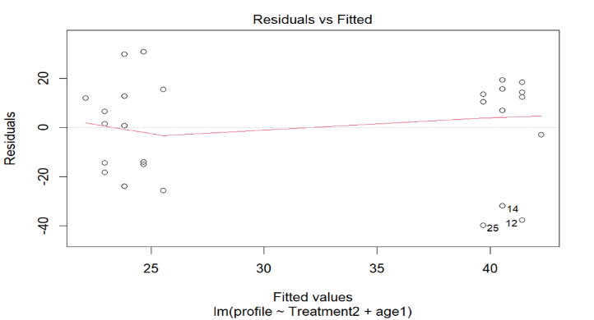

Figure 3. Residuals vs. fitted plot for profile front duration linear model

The spread of the residuals is random around 0 and the red trend line of residuals is approximately flat. This suggests the normality of residuals.

Figure 4. Residuals vs. fitted plot for stare front duration linear model

The spread of the residuals is random around and the red line of residuals is approximately flat. This suggests the normality of residuals.

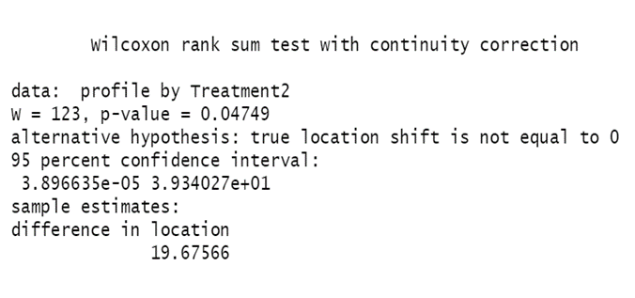

Figure 5. The Mann Whitney U-test results show that the 95% confidence interval does not include 0 as possible median of all difference between MIA and control group’s profile front duration. This suggests that the distributions of profile front duration of MIA and control group are not identical and profile front duration at 1 month is significantly different across treatment group (p = 0.047).

Figure 6. The Mann Whitney U-test results show that the 95% confidence interval includes 0 as possible median of all difference between MIA and control group’s stare front duration. This suggests that the distributions of stare front duration of MIA and control group are identical and stare front duration at 1 month is not significantly different across treatment group (p = 0.11).